**University of Petroleum and Energy Studies**

School of Computer Science

Department of Cybernetics



**Graphics & Animation Tools**

**Project Report**

**(Session: 2020-2021)**

Course: B. Tech with Specialization in Open Source and Open Standards

Batch: 2017-2021

Semester: VIIth

**Submitted By:**

Ananya Raghav

R100217008

500062570

**Submitted To:**

Dr. Durgansh Sharma Assistant Professor

Department of Cybernetics

**Aim:** Design of 3D Futuristic Space Scene using Blender.

**Steps followed:**

1. Open Blender.
2. Clear the default interface of the blender by deleting or hiding the cube.
3. To create a plane, press Shift+A and select plane.
4. Scale the plane in x and y direction to make it bigger.
5. Now, hit tab and select subdivide on left click and then select the no. Of cuts you want on the plane, in this case, I have used 30 subdivisions.

This step will divide your plane into 30 subdivisions.

1. Add mountains, click on Proportional editing on the top, on the circle click connected and then random.
2. Click and hold shift on the plane to get some spots around the edges on both the sides.
3. Now scale the spots by using the scroller view, we finally have the spikes now.
4. Now to elongate the path and make it look like an endless loop, press Shift+A, go to empty, add a plane axis, hold down control and reach the extreme end of the plane.
5. Click on the plane and add a new modifier Mirror, click on empty in mirror object and uncheck X axis and check the Y axis.

Now, our long-mirroredplane is ready.

1. Now, we have to add camera, click on camera, hold down shift and bring it all the way to the edge.
2. To add animations, check frame rate is 24fps and at the bottom change the end to 120 for 5 second animation.
3. Go to preferences, inside Animation your default interpolation is linear.
4. Click on camera, click on the keyframe and click all the way to the edge of the animation and then click on the right arrow once.
5. Hold down ctrl and bring it to the edge and then click a key frame.
6. Now, add array modifier, change the values in relative offset and set counts to 10. It now loops seamlessly.
7. Here, comes the designing part, add the classic wireframes and uncheck replace original.
8. To add material, check metallic and then add emission shader by clicking on + and choose the colour of your choice.
9. Go to wireframe modifier and click material offset 2 and click Z. And, the effect is ready.
10. Now, from HRDI haven pick a sky for the background and download it, now click on the world settings. Click on nodes, click colour and click environment texture.
11. Now, get the shader editor in a new window and hit 0 to get a clear view.
12. In the shading editor, go to world and add a mapping node and a texture coordinate node and put the generated to the vector and the vector to the vector, and scale it around and Z and X to balance the view.
13. Behind the background node, click Shift+A, click on colour, click hue saturation and place it right there.
14. If you want to change the colour of the sky, change it by adjusting the hue.
15. Now, got to layout, click on mountains, click tab and select some vertices to make the ground the bumpy, while the proportional editing is on.
16. Now go to shader, click on material, go back to the shading preset, click on object and add a bump node to the ground.
17. To add sun, get a UV sphere by Shift + A and then clicking on UV Sphere, click o shade smooth and bring it somewhere in between, not at the end.
18. Now, scale the sphere as per the requirements.
19. To colour the sphere, go to shader, select emission and select the colour orange.
20. Select sphere, select the camera and then click Ctrl+P.
21. Click on the object so that it’s in the horizon to give optical illusion effect.
22. Now, for rendering, go to ‘output properties’, select ‘Output’ and click on ‘folder icon’ to set your output video location (e.g. Desktop) and then click on file format, change it to ‘FFmpeg video’.
23. Finally,go to ‘Render’ and click on ‘Render Animation’, your video(.mkv) file will be exported on Desktop.

**OUTPUT:**

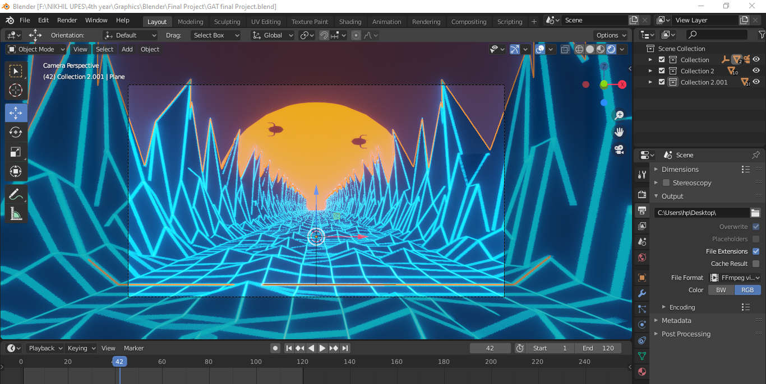

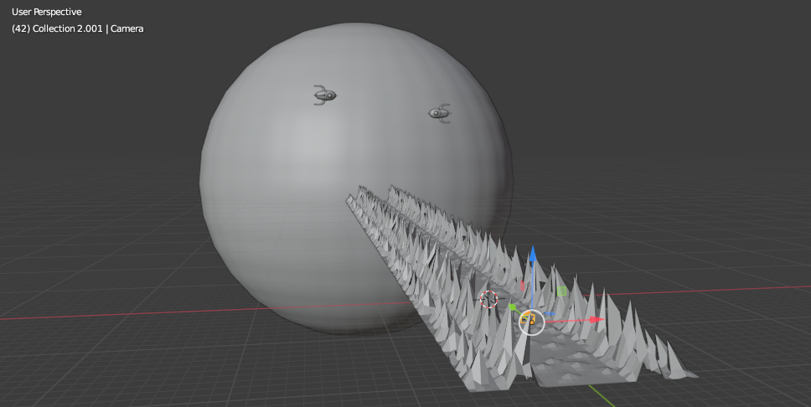

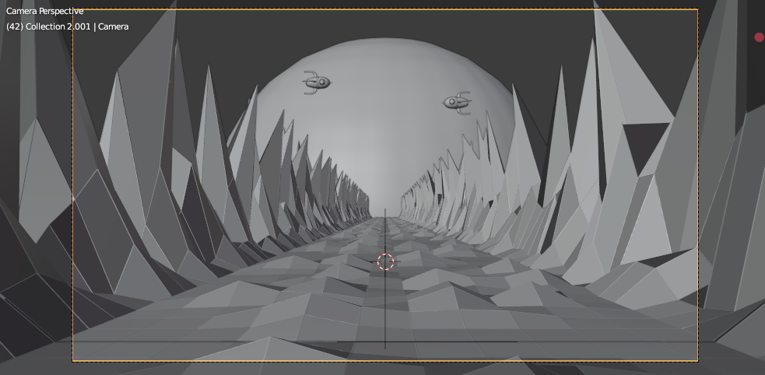

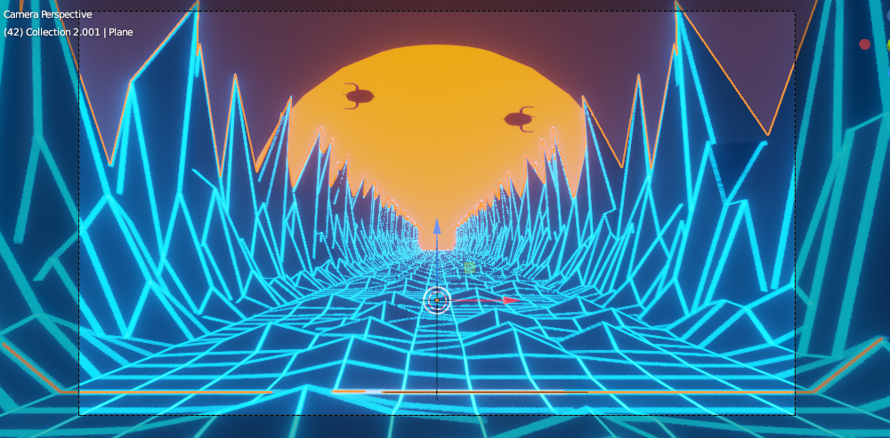

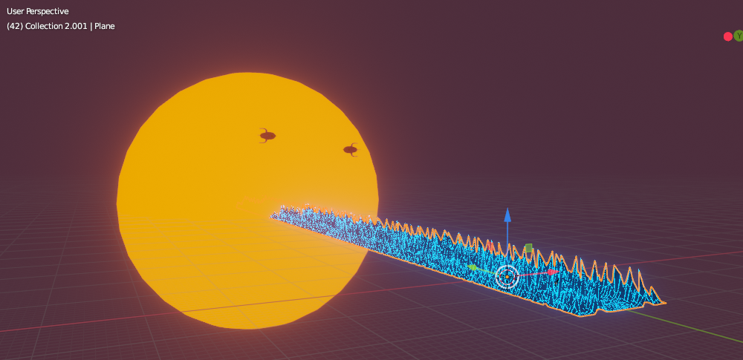

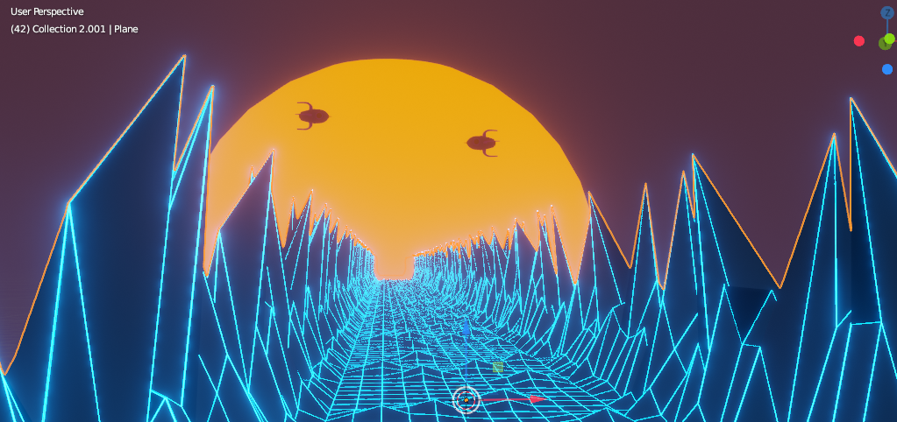

**Google Drive Link:** [**https://drive.google.com/drive/folders/1RDb6PfRmFg7ghnCJLN-RrEwjonw5bmpQ?usp=sharing**](https://drive.google.com/drive/folders/1RDb6PfRmFg7ghnCJLN-RrEwjonw5bmpQ?usp=sharing)